

*News Letter Civil Department*

*CESA*

Department of Civil engineering

Shree datta polytechnic college ,dattanagar, shirol

[www.dattapolytechnic.com](http://www.dattapolytechnic.com)

mail id- sdpccivil2020@gmail.com

**DEPARTMENT OF CIVIL ENGINEERING**

Vision

To be among the top notch Civil Engineering department in India, create center of excellence to provide globally competent Civil engineering graduates serving the needs of the society and sustainable development. The department will make significant contribution to the economic development of the state, region and nation.

Mission

1. To create atmosphere for teaching and continuous learning, research, consultancy and developmental activities through excellent teaching, research and state of the art infrastructure.
2. To impart professionalism among students, through industry institute interaction.
3. To imbibe leadership quality, professional ethics, environmental consciousness and social responsibilities to serve the society through co-curricular and extra-curricular activities.
4. To prepare Civil Engineering students for successful professional careers.

From the HOD’s Desk...

It gives me immense pleasure to note that another edition of Electro vision is ready for launch. Truly, irrespective of class or cadre or caliber, it is the dynamism and pervasiveness of the vision that can lead to sustainable excellence. The big theme today is to focus on creativity and innovation alongside academics. Entrepreneurial wealth creation has been explosive on account of the massive impact made by technology start-ups. It is research and development that fosters innovation and out of the box thinking, be it in design or in implementation. Interact with your predecessors pursuing their passions as entrepreneurs or as employees and they would vouch for the fact that career progression or wealth creation happens only when the vision extends beyond the periphery. Apply your mind in everything you do, whether it is a small laboratory project or a longer semester project. Understand the “Why”, investigate the “Why not” and think through the “How else” and you would already have become an Inventor or Pioneer. Blend some street smart business sense to the whole thing and you would have transcended to an entrepreneur!!! Wealth creation is meaningless unless it heralds prosperity for posterity. That warrants ethical responses from all stakeholders. That also demands an aspiration to see from a larger canvas and for a longer horizon. Or in other words, flavor your business offering with a sense of ethics and generations will call you a Visionary

Best Wishes…

Mr. N. B. BHOLE

HOD, CIVIL Department

*Toppers of Summer 2023 Exam*

**Topper of first Year Class**

|  |  |  |  |
| --- | --- | --- | --- |
| Sr.No | Name of student | Rank | Marks |
| **1** | **Kamble Satyam Bajrang** | **1ST** | **68.84** |

**Topper of Second Year Class**

|  |  |  |  |
| --- | --- | --- | --- |
| Sr.No | Name of student | Rank | Marks |
| **1** | **Makandar Mirasab Fakruddin** | **1ST** | **70.25** |

**Topper of Third Year Class**

|  |  |  |  |
| --- | --- | --- | --- |
| Sr.No | Name of student | Rank | Marks |
| **1** | **Fadatare Tejas Shivaji** | **1ST** | **74.37** |

**Congratulations!!!**

STUDENT PARTICIPATED IN DIFFERENT ACTIVITIES

A state level WEBINAR was arranged by TSSM’s BSCOER ON 18.03.2024in which faculty and students participated as follows.

|  |  |  |  |
| --- | --- | --- | --- |
| SR. NO. | NAME OF Staff / STUDENT | VENUE | REMARK |
| 1 | Nilkanth Baburao Bhole | SDPC, Shirol | PARTICIPATED |
| 2 | Vikramsingh P.Rajput | SDPC, Shirol | PARTICIPATED |
| 3 | Siddharth Deepak shinde | SDPC, Shirol | PARTICIPATED |
| 4 | Kale Sandesh Sharad | SDPC, Shirol | PARTICIPATED |
| 5 | Patil Meghraj Rajendra | SDPC, Shirol | PARTICIPATED |
| 6 | Gavle Shubham Hanmant | SDPC, Shirol | PARTICIPATED |
| 7 | Mathpati Akanksha Anil | SDPC, Shirol | PARTICIPATED |

The students participated in ‘Model Making’competition in event Digifest Aakar on 23.2.2024.

|  |  |  |  |
| --- | --- | --- | --- |
| SR. NO. | NAME OF STUDENT | VENUE | REMARK |
| 1 | Chavan Vivek Arvind | New Polytechnic, Kolhapur | PARTICIPATED |
| 2 | Patil Sammed Ramgonda | New Polytechnic, Kolhapur | PARTICIPATED |
| 3 | Chougule Koushik Jagdish | New Polytechnic, Kolhapur | PARTICIPATED |
| 4 | Thomake Atharva Jalindar | New Polytechnic, Kolhapur | PARTICIPATED |

The students participated in ‘MSBTE sponsored State Level Technical Paper Presentation Competition’ oraganized by SBGI, Miraj on 1.2.2024.

|  |  |  |  |
| --- | --- | --- | --- |
| SR. NO. | NAME OF STUDENT | VENUE | REMARK |
| 1 | Patil Meghraj Rajendra | SBGI POLYETCHNIC, MIRAJ | PRESENTED |
| 2 | Gavle Shubham Hanmant | SBGI POLYETCHNIC, MIRAJ | PRESENTED |

Faculty Attended

Trainings & workshops

1. Nilkanth Baburao Bhole has participated in the National Level Webinar on "BUSINESS SKILLS NEEDED TO THRIVE IN THE 21st CENTURY" held on 28th August 2023

1. Nilkanth Baburao Bhole has compeleted two days STTP on ‘Blast Resistant Design and Intelligent Transportation System’.

2. Vikramsingh P.Rajput has compeleted two days STTP on ‘Blast Resistant Design and Intelligent Transportation System’.

3. Narendra N. Kulkarni has compeleted two days STTP on ‘Blast Resistant Design and Intelligent Transportation System’.

4. Mrs. Pooja P. Upadhye has compeleted two days STTP on ‘Blast Resistant Design and Intelligent Transportation System’.

5. Miss. N. A. Kale has compeleted two days STTP on ‘Blast Resistant Design and Intelligent Transportation System’.

7. Kulkarni Shivanand Mohan has completed FDP on ‘Right to Information and Good Governance’.

***Our students are placed in various reputed companies with attractive package.***

|  |  |  |
| --- | --- | --- |
| **Company Name** | **No of Students** | **Package** |
| Rohan Builders, Pune | 01 | 2.53 Lacs/year |
| JMRC, SURAT | 01 | 2.4 Lacs/year |
| Gunjate Construction Sangli | 01 | 2.4 Lacs/year |
| Pmgsy, Kolhapur, Civil Engg. Assistant | 01 | 2.5 Lacs/year |

|  |  |  |  |
| --- | --- | --- | --- |
| **SR. NO** | **Name of the student** | **College name** | **Industry Name** |
| 1 | Makandar Mirasab Fakruddin | SDPC, SHIROL | Rohan Builders, Pune |
| 2 | Patil Shrivardhan Sanjay | SDPC, SHIROL | JMRC, SURAT |
| 3 | Fadatare Tejas Shivaji | SDPC, SHIROL | Gunjate Construction Sangli |
| 4 | Koli Ravindra Vidyashankar | SDPC, SHIROL | Pmgsy, Kolhapur, Civil Engg. Assistant |

Congratulations!!!!!

Industrial Visits

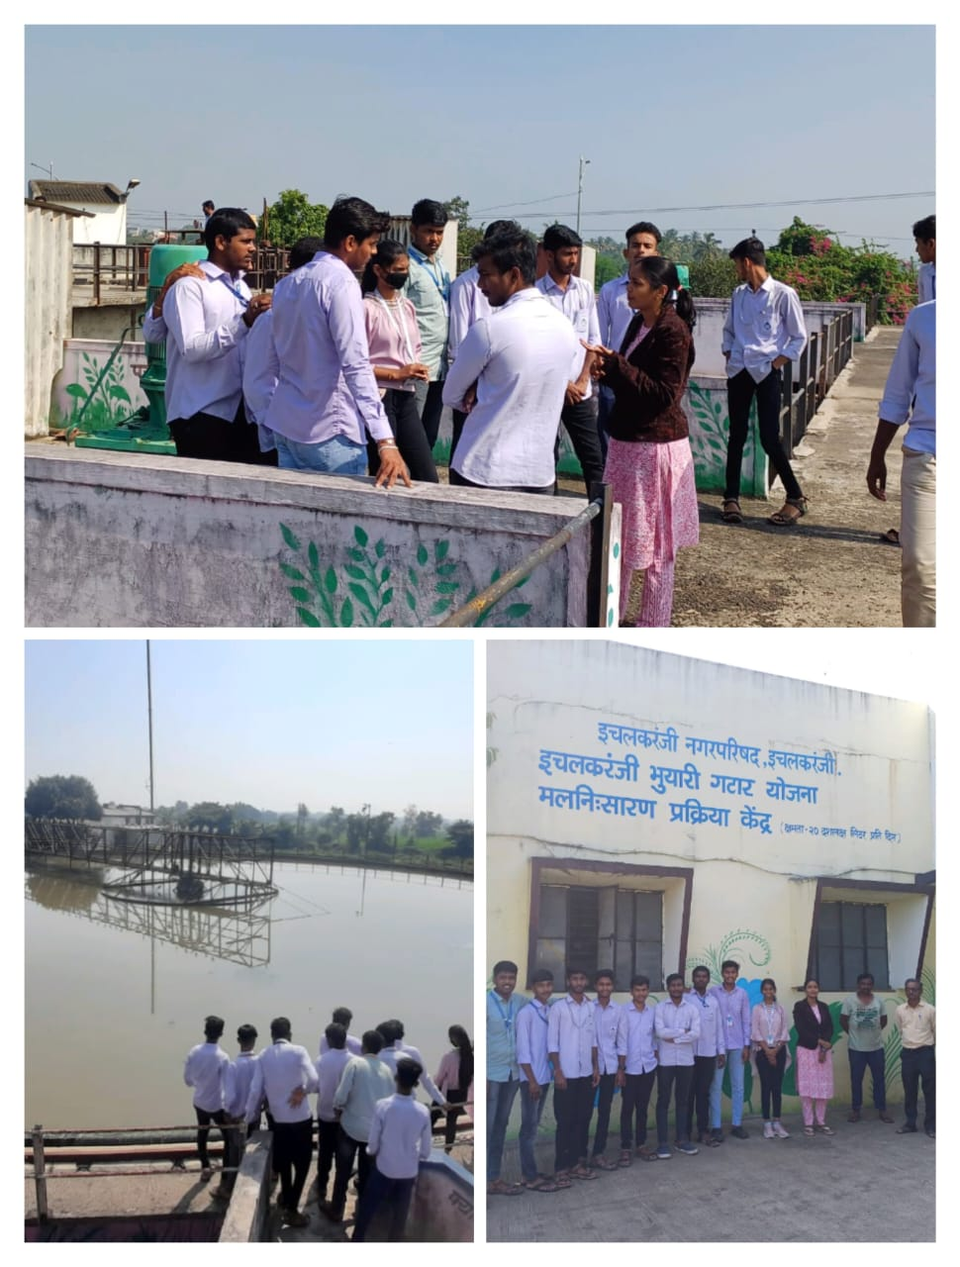 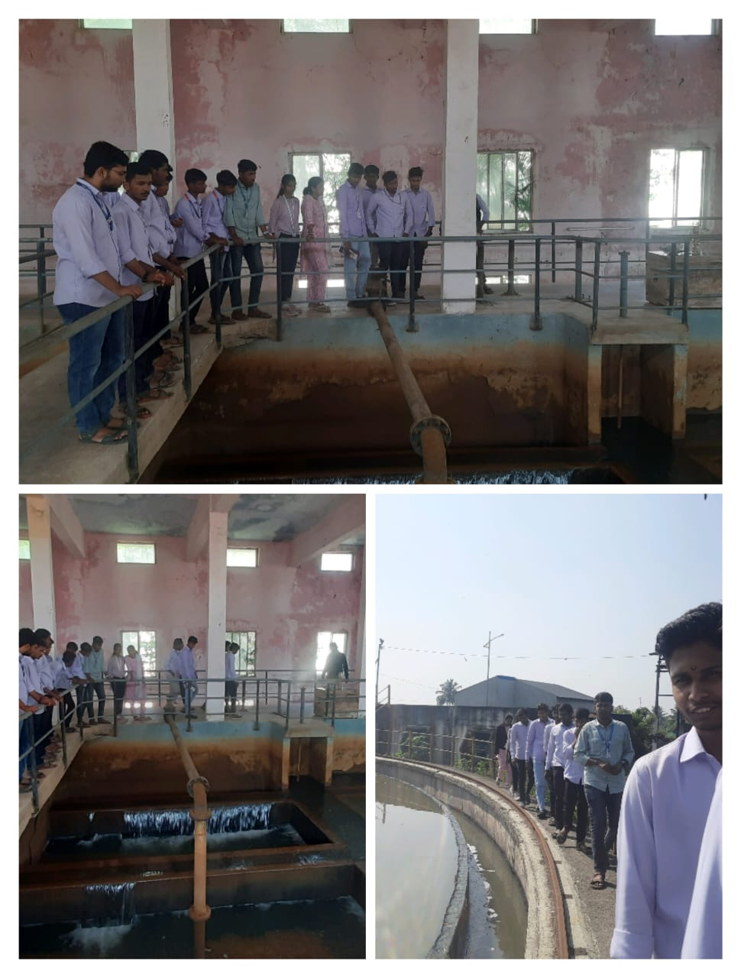

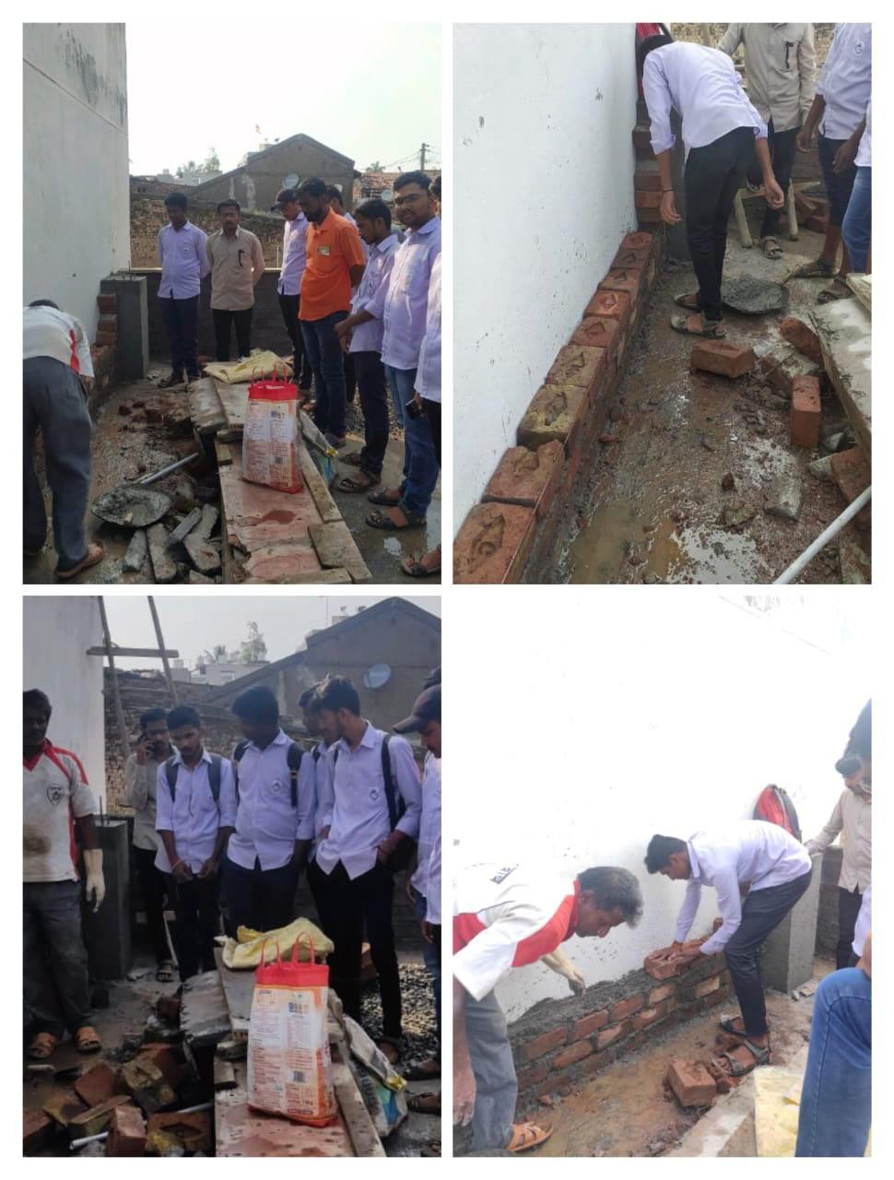 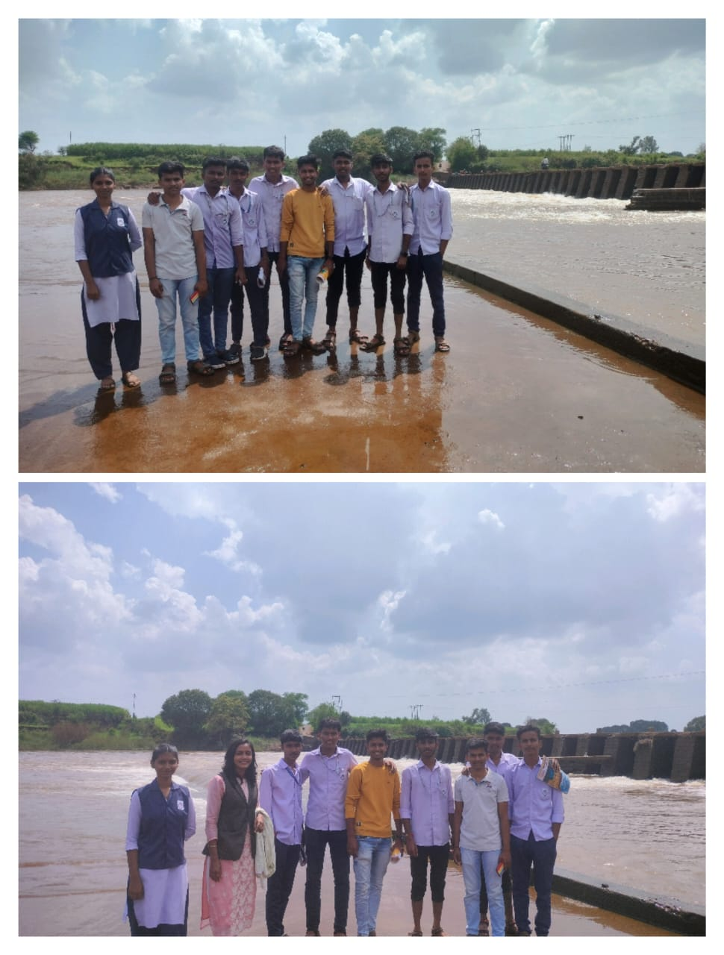

Thank you